**CURRICULUM VITAE**

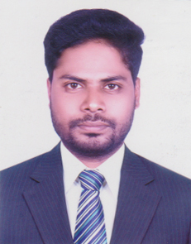

**OF**

**MD. ABDUR RAHMAN**

**MAILING ADDRESS**

House# 1042/A-3, Road# 16/A,

Adabor, Mohammadpur, Dhaka- 1207.

Cell: 01749949341

**CAREER OBJECTIVE:**

To Work in an organization Where discipline and high-tech environment will ensure fast career development and the congenial atmosphere will set up to managerial qualities that is vision, positive attitude, interpersonal relationship, communication skills, attitude to take challenges and commitment to achieve results.

**EDUCATION QUALIFICATION**

**Bachelor of business Administration (B.B.A)**

Institute : Mohammadpur Kendriya College

University : National University

Subject : Marketing

Result : 3.06 (out of 4.00)

Passing Year : 2015

**Higher Secondary Certificate (H.S.C.)**

Institute : Mohammadpur Kendriya College

Board : Dhaka

Group : Business Studies

Result : 4.40 (out of 5.00)

Year of Passing : 2011

**Secondary School Certificate (S.S.C.)**

Institute : Dhaka Presidency School

Board : Dhaka

Group : Business Studies

Result : 3.38 (out of 5.00)

Year of Passing : 2008

**LANGUAGE PROFICIENCY:**

|  |  |  |  |
| --- | --- | --- | --- |
| **Language** | **Reading** | **Writing** | **Speaking** |
| Bangla | Excellent | Excellent | Fluent |
| English | Excellent | Excellent | Fluent |

**Computer Literacy:**

* Operating System: Windows 2007, 10
* Application Software: MS-Word, Excel, Internet Browsing etc.

**PERSOAL INFORMA TION**

Father’s Name : Md. Abdul Latif

Mother’s Name : Minu Begum

Date of Birth : 20/04/1993

Religion : Islam

Gender : Male

Marital Status : married

Nationality : Bangladeshi (By Birth)

Permanent Address : Vill: Katchubaria P.O: South Chargachia

P.S: Matbaria , Dist: Pirojpur,

**Experience**

I have been working as a Assistant Accountant in RRF to 6th Month.

I have been working as a SR in Arla foods to 1 Years.



**Signature**

**Date: 06/08/2018**